

***Java Technologies for Web Applications***

**Project Assignment**

|  |  |
| --- | --- |
| Document Code | 25e-BM/HR/HDCV/FSOFT |
| Version | 1.1 |
| Effective Date | 20/11/2012 |

**Hanoi, 04/2019**

RECORD OF CHANGES

|  |  |  |  |  |  |
| --- | --- | --- | --- | --- | --- |
| No | Effective Date | Change Description | Reason | Reviewer | Approver |
|  | 25/Jun/2018 | Create a new assignment | Create new | DieuNT1 | VinhNV |
|  | 01/Jun/2019 | Apply fsoft template  Update requirements: split Specification1 and 2 by training day | Update | DieuNT1 | VinhNV |
|  |  |  |  |  |  |
|  |  |  |  |  |  |
|  |  |  |  |  |  |
|  |  |  |  |  |  |
|  |  |  |  |  |  |
|  |  |  |  |  |  |
|  |  |  |  |  |  |
|  |  |  |  |  |  |

Contents

Project Assignment 4

Objectives 4

Business needs 4

Product architectures 5

Working requirements 5

Technical Requirements 5

Database Relationship 6

Specifications 1 6

Specifications 2 9

Mark scale : 10

|  |  |
| --- | --- |
|  | **CODE: JWEB.P.A103 (HR)**  **TYPE: Project Assignment**  **LOC: N/A**  **DURATION: 12 hours (completed in 3 working day)** |

# Project Assignment

Objectives

* Understand the basic concepts of web development technologies with java (JSP / Servlet)
* Able to write servlets using the Java programming language (Java servlets)
* Create dynamic HTML content with Servlets and JavaServer Pages, using the Expression Language, and the JSP Standard Tag Library (JSTL)
* Create robust web applications using MVC architecture, session management, filters, and database integration (JDBC) or Hibernate framework
* Make Servlets and JSP work together cleanly
* Create secure web applications using the features of the Java EE web container
* Deploy your project using Apache Tomcat Server

Business needs

Create a Web application bases on HTML, CSS, JavaScript, Ajax, Servlet, JSP and Hibernate framework to manage Human Resource (HR Management System). Use case Diagram as below here:



Product architectures

If you use JDBC to connect to Database, then must use the following architecture:



The architecture with Hibernate framework:

**Model/Value objects**

*(represent things in our application domain)*

**Data access layer**

*(handle saving and retrieving data as objects)*

**Presentation Layer**

*(This layer controls the display to the end user)*

HibernateUtils

**Database**

Client tier

Working requirements

Working environment:

* Eclipse IDE,
* SQL DB Server,
* Apache TomCat 8 or later,
* Internet connection,
* Apache Maven.

Delivery:

* Source code, deployment and testing evident packaged in a compress archive.

Technical Requirements

* Must use HTML/CSS, JS/jQuery, JSP/Servlet and JDBC or Hibnerate Framework

Database Relationship

The following entity-relation (ER) diagram shows the table structure and relationships about the above tables

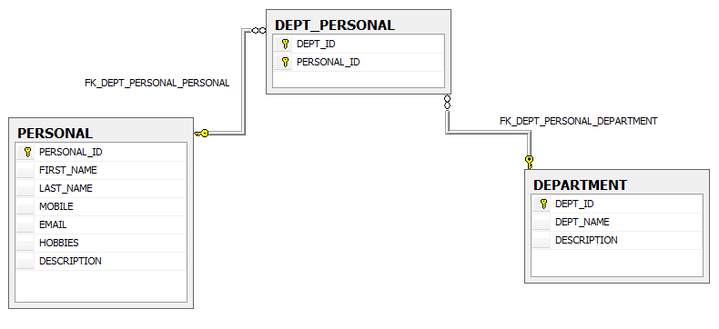

Specifications 1

1. **Create screens**

You have to create the 3 .jsp pages for a survey app, the design for each page is as below:

* *Person screen:*

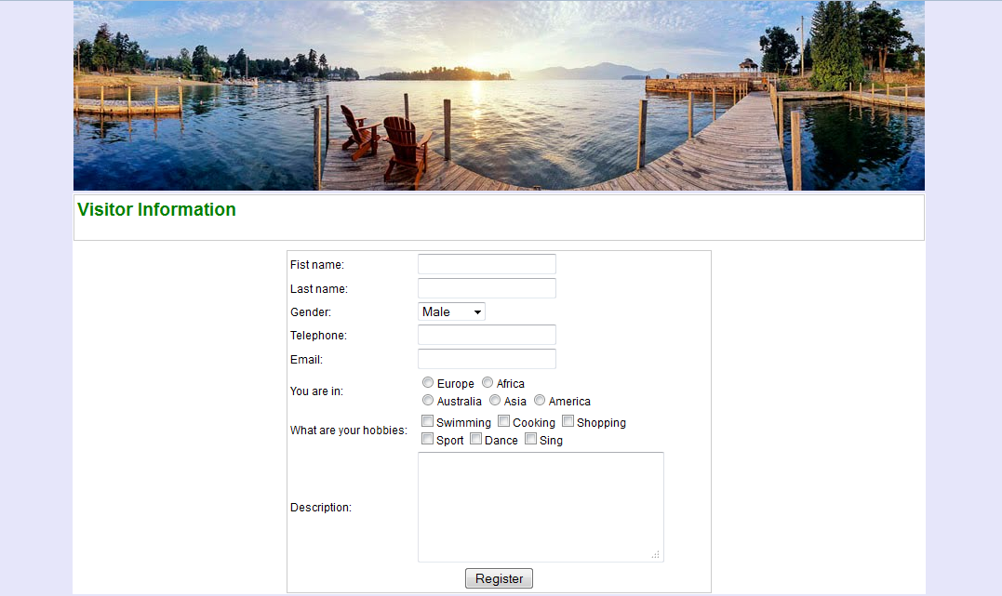

* *Search screen:*

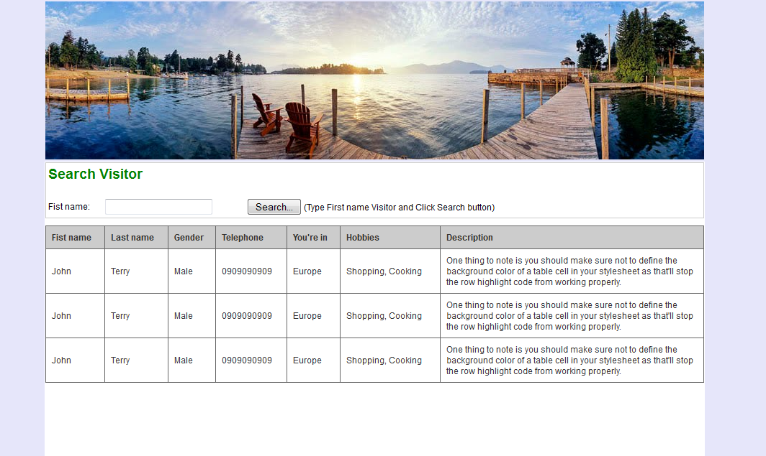

1. **Validates**

You use JQuery to write a method for validation data when you click Register button:

|  |  |  |  |
| --- | --- | --- | --- |
| **Field** | **Mandatory** | **Max length** | **Description** |
| First name | Y | 20 | -First name must be characters and not contain number |
| Last name | Y | 20 | -Last name must be characters and not contain number |
| Telephone | N | 11 | Must be number |
| Email | N | 50 | Must be [a..Z][0..9]@[a..Z]. |
| You are in | Y |  |  |
| Hobbies | N |  |  |
| Description | N | 200 |  |

Click “Help to register” link, using Ajax to display content help.jsp file

Specifications 2

In this specification of assignment, you must to finish all feature in bellow Use case:



* **Insert:** allows creating one a more Personal Information from Person page. Personal Information will be stored in “Personal” table in DataBase
* **Search:**
  + Input “First name” and click Search button. The Result will be listed in grid table.
* **Amend (***Edit/Delete***):** From Search Screen, input “first name” then click “Search” button and list result. Choose an item (*by clicking First name link*) from list to Amend. Using Tomcat server to deploy and run project.

*Amend screen:*

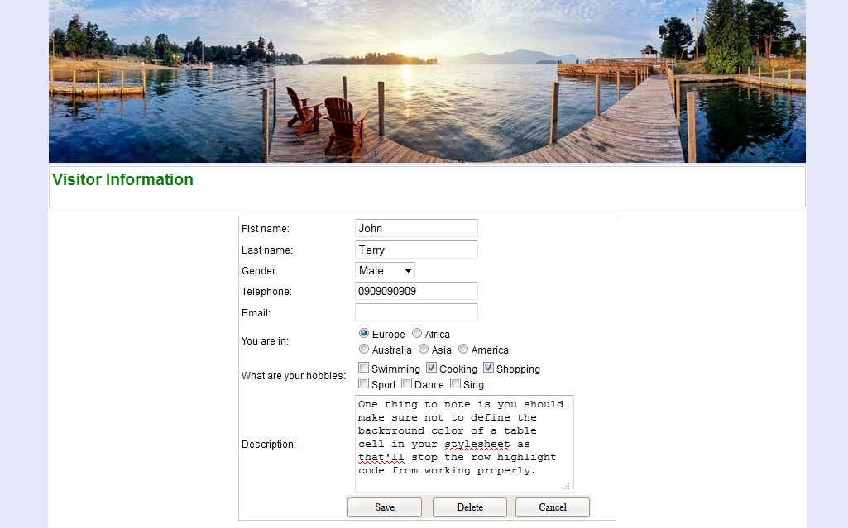

User modifies information and click “Save” button to edit. If User want to delete this person, click “Delete” button

Click “Cancel” button to return Search screen.

Deploy your application into Tomcat server.

Mark scale :

|  |  |
| --- | --- |
| * Create project with architectures, Configuration, Mapping : 20% * Specification 1 : 30% | * Specification 2 : 40% * Non-Functional, Quality requirements: 10% |

**-- THE END --**